ORCHESTRA
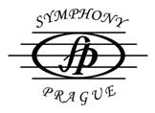
SYMPHONY PRAGUE
Concert:
GERMANY: Stechau
DATE: 28 juli 2012 at 8 p.m.
VENUE: chateau Stechau (open – air)
conductor: Stefan Britvik
soloist: Miroslav Vilimec, violin
soloist: Petr Nemecik, bassoon
FESTIVAL “BRANDENBURGISCHE SOMMERKONZERTE“
PROGRAMME:
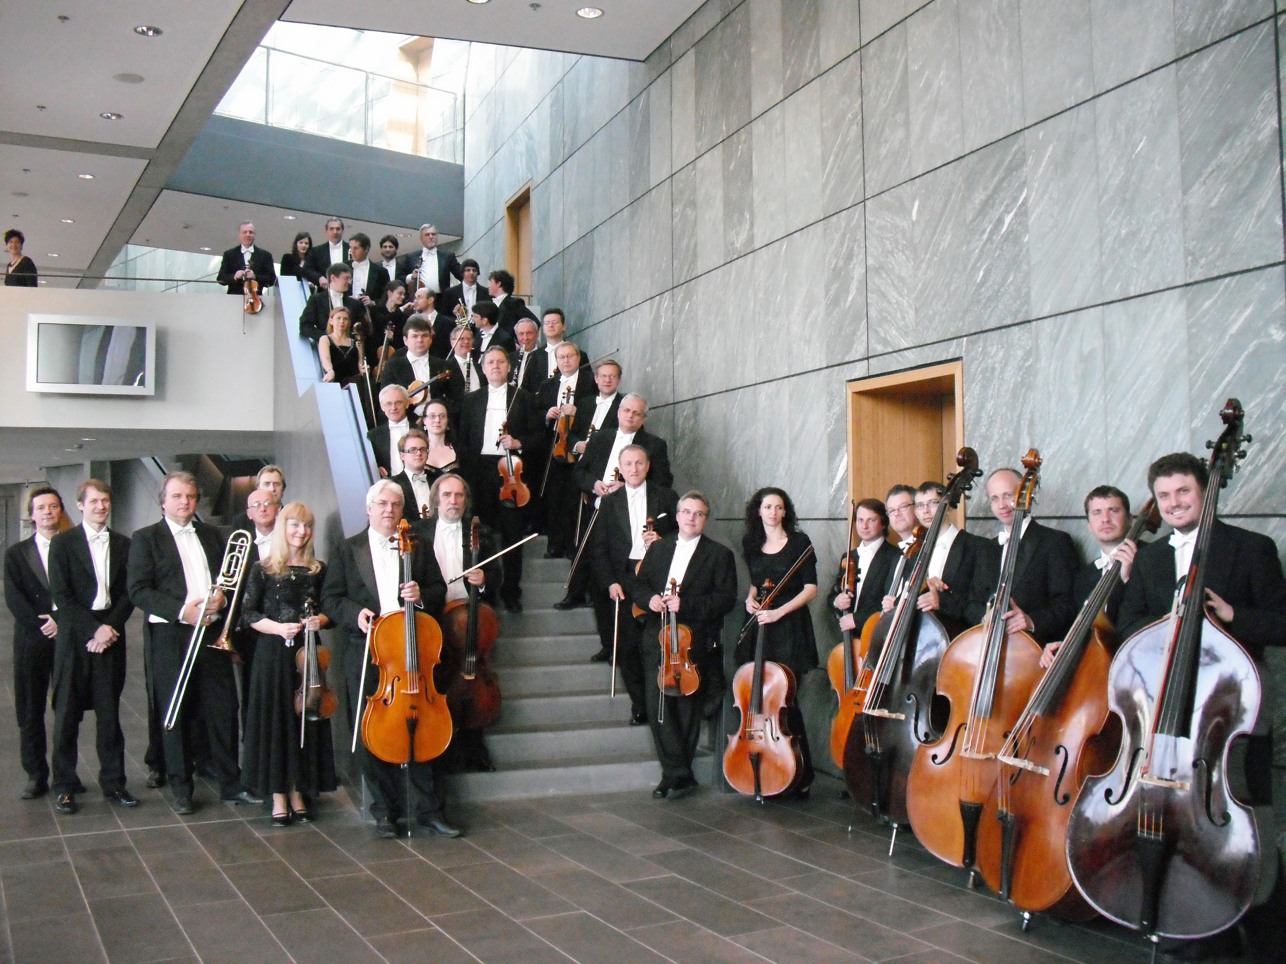
L.van Beethoven: Fidelio - Overture
L.van Beethoven: Romance for violin und orchestra Nr.2, in F major , (Miroslav Vilimec)
C.M.von Weber: Concert for basson and orchestra in F major ( Petr Nemecek)
. .......................................................................................
A.Dvorak: Symphony Nr. 8
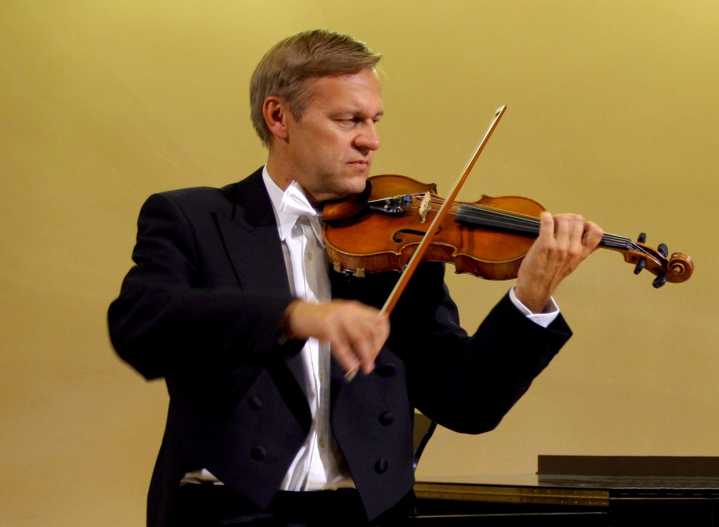
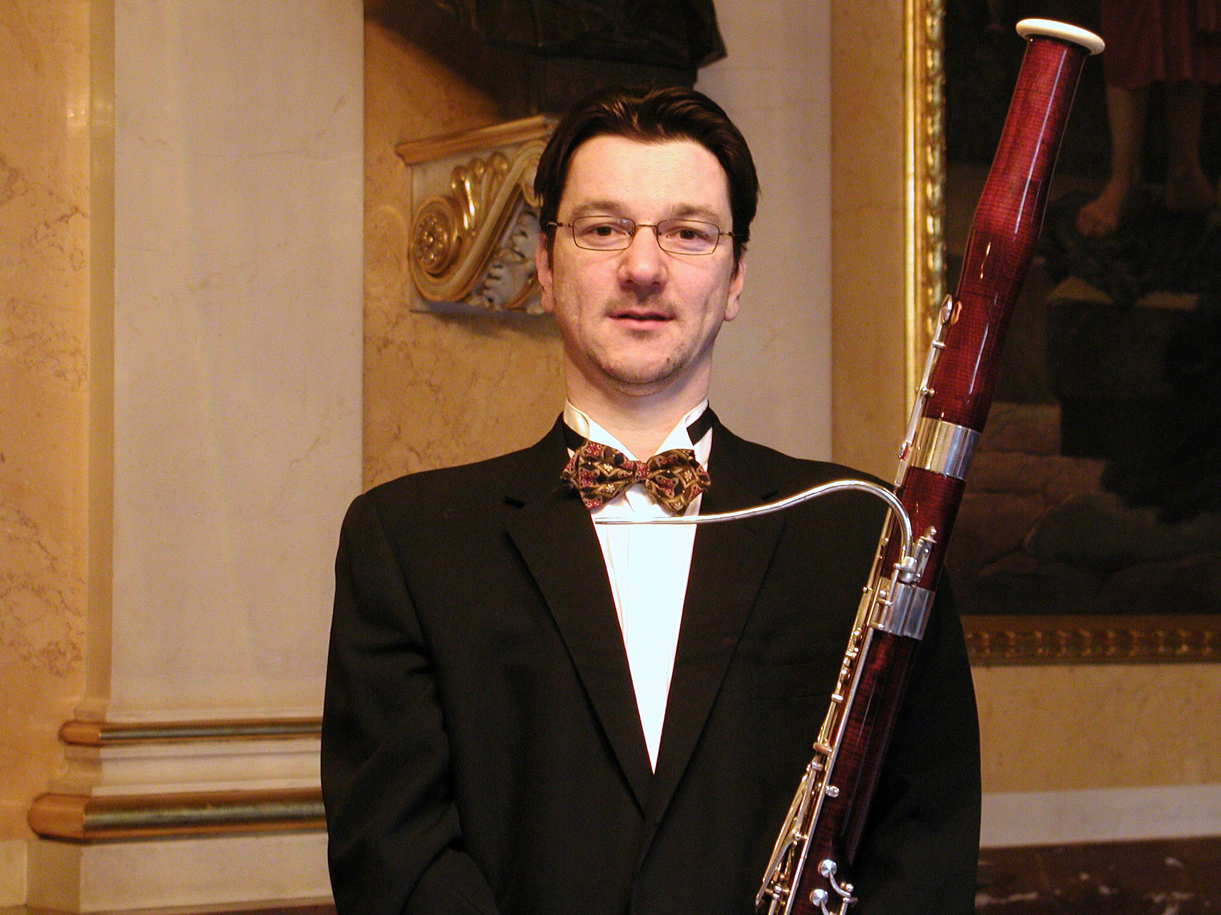
MIROSLAV VILIMEC, violin PETR NEMECEK, bassoon

