ORCHESTRA
SYMPHONY PRAGUE
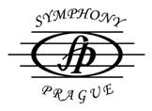
Concert:
Czech Republic: PRAGUE
DATE: 29 September 2012 at 5 p.m.
VENUE: St. Nikolas Church on Lesser Town
conductor: Stefan Britvik
in cooperation with: Chamber Czech Radio Choir and soloist

PROGRAMME:
W.A.Mozart: Te Deum KV 141
Brustman: Moteto Ego Venceslaus
Josef Suk: Meditaton on St. Wenceslas choral, op. 35a
F.Schubert: Mass Nr. 2 in G major (D 167)


